- 1. Question
1 points
During a routine inspection, a technician discovered that software that was installed on a computer was secretly collecting data about websites that were visited by users of the computer. Which type of threat is affecting this computer?
  - DoS attack​
  - identity theft
  - spyware
  - zero-day attack
- 2. Question
1 points
Which term refers to a network that provides secure access to the corporate offices by suppliers, customers and collaborators?
  - Internet
  - intranet
  - extranet
  - extendednet
- 3. Question
1 points
A large corporation has modified its network to allow users to access network resources from their personal laptops and smart phones. Which networking trend does this describe?
  - cloud computing
  - online collaboration
  - bring your own device
  - video conferencing
- 4. Question
1 points
What is an ISP?
  - It is a standards body that develops cabling and wiring standards for networking.
  - It is a protocol that establishes how computers within a local network communicate.
  - It is an organization that enables individuals and businesses to connect to the Internet.
  - It is a networking device that combines the functionality of several different networking devices in one.
- 5. Question
1 points
Match the requirements of a reliable network with the supporting network architecture. (Not all options are used.)
Sort elements
  - fault tolerance
  - security
  - scalability
  - Nothing
  - Nothing

Protect the network from unauthorized access.

Provide redundant links and devices.

Match the type of communication with a specific priority.

Expand the network without degrading the service for existing users.

Ensure that streaming data is provided over high speed links.
- 6. Question
1 points
An employee at a branch office is creating a quote for a customer. In order to do this, the employee needs to access confidential pricing information from internal servers at the Head Office. What type of network would the employee access?
  - an intranet
  - the Internet
  - an extranet
  - a local area network
- 7. Question
1 points
Which statement describes the use of powerline networking technology?
  - New “smart” electrical cabling is used to extend an existing home LAN.
  - A home LAN is installed without the use of physical cabling.
  - A device connects to an existing home LAN using an adapter and an existing electrical outlet.
  - Wireless access points use powerline adapters to distribute data through the home LAN.
- 8. Question
1 points
A networking technician is working on the wireless network at a medical clinic. The technician accidentally sets up the wireless network so that patients can see the medical records data of other patients. Which of the four network characteristics has been violated in this situation?
  - fault tolerance
  - scalability
  - security
  - Quality of Service (QoS)
  - reliability
- 9. Question
1 points
Match each characteristic to its corresponding Internet connectivity type. (Not all options are used.)
Sort elements
  - not suited for heavily wooded areas
  - high bandwidth connection that runs over telephone line
  - uses coaxial cable as a medium
  - typically uses a T1/E1 or T3/E3 circuit
  - typically has very low bandwidth

DSL

dialup telephone

satellite

cable
- 10. Question
1 points
What two criteria are used to help select a network medium from various network media? (Choose two.)
  - the types of data that need to be prioritized
  - the cost of the end devices utilized in the network
  - the distance the selected medium can successfully carry a signal
  - the number of intermediate devices installed in the network
  - the environment where the selected medium is to be installed
- 11. Question
1 points
What type of network traffic requires QoS?
  - email
  - on-line purchasing
  - video conferencing
  - wiki
- 12. Question
1 points
A user is implementing security on a small office network. Which two actions would provide the minimum security requirements for this network? (Choose two.)
  - implementing a firewall
  - installing a wireless network
  - installing antivirus software
  - implementing an intrusion detection system
  - adding a dedicated intrusion prevention device
- 13. Question
1 points
Passwords can be used to restrict access to all or parts of the Cisco IOS. Select the modes and interfaces that can be protected with passwords. (Choose three.)
  - VTY interface
  - console interface
  - Ethernet interface
  - boot IOS mode
  - privileged EXEC mode
  - router configuration mode
- 14. Question
1 points
Which interface allows remote management of a Layer 2 switch?
  - the AUX interface
  - the console port interface
  - the switch virtual interface
  - the first Ethernet port interface
- 15. Question
1 points
What function does pressing the Tab key have when entering a command in IOS?
  - It aborts the current command and returns to configuration mode.
  - It exits configuration mode and returns to user EXEC mode.
  - It moves the cursor to the beginning of the next line.
  - It completes the remainder of a partially typed word in a command.
- 16. Question
1 points
While trying to solve a network issue, a technician made multiple changes to the current router configuration file. The changes did not solve the problem and were not saved. What action can the technician take to discard the changes and work with the file in NVRAM?
  - Issue the reload command without saving the running configuration.
  - Delete the vlan.dat file and reboot the device.
  - Close and reopen the terminal emulation software.
  - Issue the copy startup-config running-config command.
- 17. Question
1 points
An administrator uses the Ctrl-Shift-6 key combination on a switch after issuing the ping command. What is the purpose of using these keystrokes?
  - to restart the ping process
  - to interrupt the ping process
  - to exit to a different configuration mode
  - to allow the user to complete the command
- 18. Question
1 points
Refer to the exhibit. A network administrator is configuring access control to switch SW1. If the administrator uses a console connection to connect to the switch, which password is needed to access user EXEC mode?
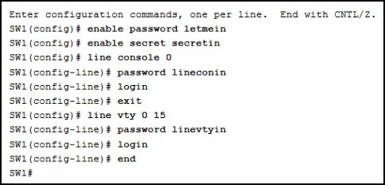
  - letmein
  - secretin
  - lineconin
  - linevtyin
- 19. Question
1 points
A technician configures a switch with these commands:
SwitchA(config)# interface vlan 1
SwitchA(config-if)# ip address 192.168.1.1 255.255.255.0
SwitchA(config-if)# no shutdown
What is the technician configuring?
  - Telnet access
  - SVI
  - password encryption
  - physical switchport access
- 20. Question
1 points
Which command or key combination allows a user to return to the previous level in the command hierarchy?
  - end
  - exit
  - Ctrl-Z
  - Ctrl-C
- 21. Question
1 points
What are two characteristics of RAM on a Cisco device? (Choose two.)
  - RAM provides nonvolatile storage.
  - The configuration that is actively running on the device is stored in RAM.
  - The contents of RAM are lost during a power cycle.
  - RAM is a component in Cisco switches but not in Cisco routers.
  - RAM is able to store multiple versions of IOS and configuration files.
- 22. Question
1 points
Which two host names follow the guidelines for naming conventions on Cisco IOS devices? (Choose two.)
  - Branch2!
  - RM-3-Switch-2A4
  - Floor(15)
  - HO Floor 17
  - SwBranch799
- 23. Question
1 points
How is SSH different from Telnet?
  - SSH makes connections over the network, whereas Telnet is for out-of-band access.
  - SSH provides security to remote sessions by encrypting messages and using user authentication. Telnet is considered insecure and sends messages in plaintext.
  - SSH requires the use of the PuTTY terminal emulation program. Tera Term must be used to connect to devices through the use of Telnet.
  - SSH must be configured over an active network connection, whereas Telnet is used to connect to a device from a console connection.
- 24. Question
1 points
An administrator is configuring a switch console port with a password. In what order will the administrator travel through the IOS modes of operation in order to reach the mode in which the configuration commands will be entered? (Not all options are used.)
  - 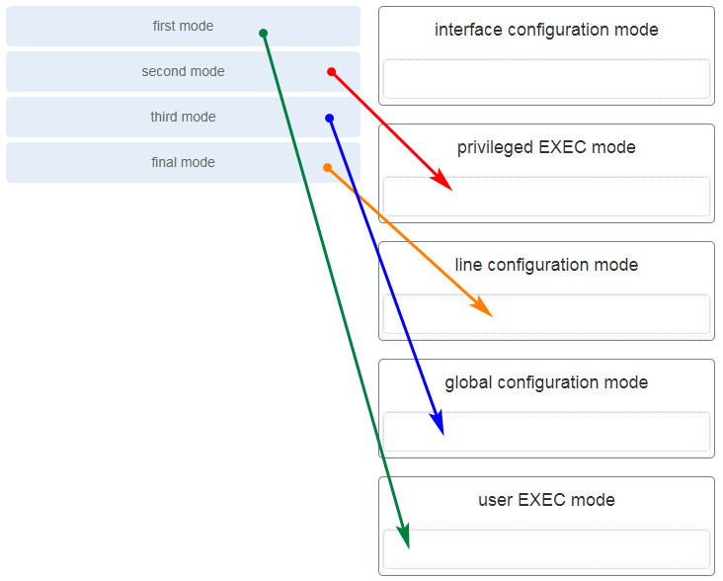
- 25. Question
1 points
What are three characteristics of an SVI? (Choose three.)
  - It is designed as a security protocol to protect switch ports.
  - It is not associated with any physical interface on a switch.
  - It is a special interface that allows connectivity by different types of media.
  - It is required to allow connectivity by any device at any location.
  - It provides a means to remotely manage a switch.
  - It is associated with VLAN1 by default.
- 26. Question
1 points
What command is used to verify the condition of the switch interfaces, including the status of the interfaces and a configured IP address?
  - ipconfig
  - ping
  - traceroute
  - show ip interface brief
- 27. Question
1 points
Match the description with the associated IOS mode. (Not all options are used.)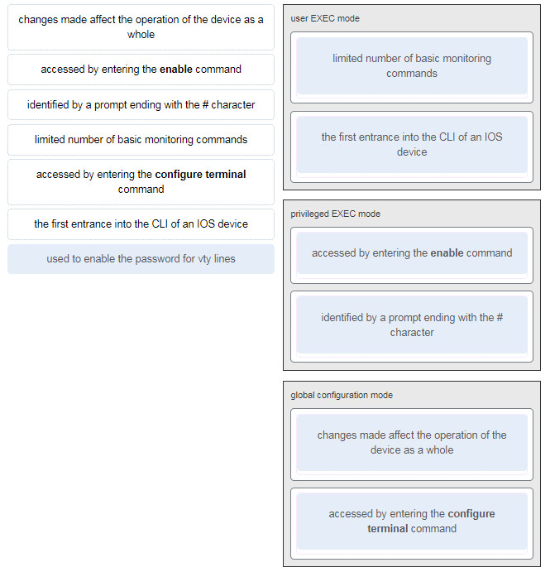
  - ...
- 28. Question
1 points
Match the definitions to their respective CLI hot keys and shortcuts. (Not all options are used.)
Sort elements
  - Ctrl-Shift-6
  - Up Arrow
  - ?
  - space bar
  - Ctrl-C
  - Tab

displays the next screen

scrolls backwards through previously entered commands

provides context-sensitive help

completes abbreviated commands and parameters

aborts commands such as trace and ping
- 29. Question
1 points
In the show running-config command, which part of the syntax is represented by running-config?
  - the command
  - a keyword
  - a variable
  - a prompt
- 30. Question
1 points
After making configuration changes on a Cisco switch, a network administrator issues a copy running-config startup-config command. What is the result of issuing this command?
  - The new configuration will be stored in flash memory.
  - The new configuration will be loaded if the switch is restarted.
  - The current IOS file will be replaced with the newly configured file.
  - The configuration changes will be removed and the original configuration will be restored.
- 31. Question
1 points
What command will prevent all unencrypted passwords from displaying in plain text in a configuration file?
  - (config)# enable password secret
  - (config)# enable secret Secret_Password
  - (config-line)# password secret
  - (config)# service password-encryption
  - (config)# enable secret Encrypted_Password
- 32. Question
1 points
A network administrator enters the service password-encryption command into the configuration mode of a router. What does this command accomplish?
  - This command encrypts passwords as they are transmitted across serial WAN links.
  - This command prevents someone from viewing the running configuration passwords.
  - This command enables a strong encryption algorithm for the enable secret password command.
  - This command automatically encrypts passwords in configuration files that are currently stored in NVRAM.
  - This command provides an exclusive encrypted password for external service personnel who are required to do router maintenance.
- 33. Question
1 points
What method can be used by two computers to ensure that packets are not dropped because too much data is being sent too quickly?
  - encapsulation
  - flow control
  - access method
  - response timeout
- 34. Question
1 points
Which statement accurately describes a TCP/IP encapsulation process when a PC is sending data to the network?
  - Data is sent from the internet layer to the network access layer.
  - Packets are sent from the network access layer to the transport layer.
  - Segments are sent from the transport layer to the internet layer.
  - Frames are sent from the network access layer to the internet layer.
- 35. Question
1 points
What three application layer protocols are part of the TCP/IP protocol suite? (Choose three.)
  - ARP
  - DHCP
  - DNS
  - FTP
  - NAT
  - PPP
- 36. Question
1 points
Match the description to the organization. (Not all options are used.)
Sort elements
  - ISOC
  - EIA
  - ISO
  - IANA

This organization is responsible for overseeing and managing IP address allocation, domain name management, and protocol identifiers.

This organization is the largest developer of international standards in the world for a wide variety of products and services. It is known for its Open Systems Interconnection (OSI) reference model.

This organization promotes the open development, evolution, and use of the Internet throughout the world.
- 37. Question
1 points
Which name is assigned to the transport layer PDU?
  - bits
  - data
  - frame
  - packet
  - segment
- 38. Question
1 points
When IPv4 addressing is manually configured on a web server, which property of the IPv4 configuration identifies the network and host portion for an IPv4 address?
  - DNS server address
  - subnet mask
  - default gateway
  - DHCP server address
- 39. Question
1 points
What process involves placing one PDU inside of another PDU?
  - encapsulation
  - encoding
  - segmentation
  - flow control
- 40. Question
1 points
What layer is responsible for routing messages through an internetwork in the TCP/IP model?
  - internet
  - transport
  - network access
  - session
- 41. Question
1 points
For the TCP/IP protocol suite, what is the correct order of events when a Telnet message is being prepared to be sent over the network?
Sort elements
  - First
  - Second
  - Third
  - Fourth

The IP header is added.

The TCP header is added.

The Ethernet header is added.

The Telnet-formatted data is provided to the next layer.
- 42. Question
1 points
Which PDU format is used when bits are received from the network medium by the NIC of a host?
  - file
  - frame
  - packet
  - segment
- 43. Question
1 points
Refer to the exhibit. ServerB is attempting to contact HostA. Which two statements correctly identify the addressing that ServerB will generate in the process? (Choose two.) 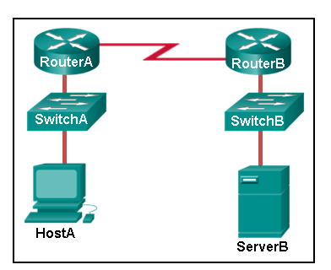
  - ServerB will generate a packet with the destination IP address of RouterB.
  - ServerB will generate a frame with the destination MAC address of SwitchB.
  - ServerB will generate a packet with the destination IP address of RouterA.
  - ServerB will generate a frame with the destination MAC address of RouterB.
  - ServerB will generate a packet with the destination IP address of HostA.
  - ServerB will generate a frame with the destination MAC address of RouterA.
- 44. Question
1 points
Which method allows a computer to react accordingly when it requests data from a server and the server takes too long to respond?
  - encapsulation
  - flow control
  - access method
  - response timeout
- 45. Question
1 points
A web client is receiving a response for a web page from a web server. From the perspective of the client, what is the correct order of the protocol stack that is used to decode the received transmission?
  - Ethernet, IP, TCP, HTTP
  - HTTP, TCP, IP, Ethernet
  - Ethernet, TCP, IP, HTTP
  - HTTP, Ethernet, IP, TCP
- 46. Question
1 points
Which two OSI model layers have the same functionality as a single layer of the TCP/IP model? (Choose two.)
  - data link
  - network
  - physical
  - session
  - transport
- 47. Question
1 points
At which layer of the OSI model would a logical address be added during encapsulation?
  - physical layer
  - data link layer
  - network layer
  - transport layer
- 48. Question
1 points
What is a characteristic of multicast messages?
  - They are sent to a select group of hosts.
  - They are sent to all hosts on a network.
  - They must be acknowledged.
  - They are sent to a single destination.
- 49. Question
1 points
Which statement is correct about network protocols?
  - Network protocols define the type of hardware that is used and how it is mounted in racks.
  - They define how messages are exchanged between the source and the destination.
  - They all function in the network access layer of TCP/IP.
  - They are only required for exchange of messages between devices on remote networks.
- 50. Question
1 points
What is an advantage of network devices using open standard protocols?
  - Network communications is confined to data transfers between devices from the same vendor.
  - A client host and a server running different operating systems can successfully exchange data.
  - Internet access can be controlled by a single ISP in each market.
  - Competition and innovation are limited to specific types of products.
- 51. Question
1 points
Which device performs the function of determining the path that messages should take through internetworks?
  - a router
  - a firewall
  - a web server
  - a DSL modem
- 52. Question
1 points
Open the PT Activity. Perform the tasks in the activity instructions and then answer the question. 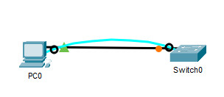What is the IP address of the switch virtual interface (SVI) on Switch0?
  - 192.168.5.10
  - 192.168.10.5
  - 192.168.10.1
  - 192.168.5.0
- 53. Question
1 points
Why would a Layer 2 switch need an IP address?
  - to enable the switch to send broadcast frames to attached PCs
  - to enable the switch to function as a default gateway
  - to enable the switch to be managed remotely
  - to enable the switch to receive frames from attached PCs
- 54. Question
1 points
Refer to the exhibit. An administrator is trying to configure the switch but receives the error message that is displayed in the exhibit. What is the problem? 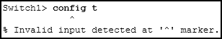
  - The entire command, configure terminal, must be used.
  - The administrator is already in global configuration mode.
  - The administrator must first enter privileged EXEC mode before issuing the command.
  - The administrator must connect via the console port to access global configuration mode.
- 55. Question
1 points
What term describes a network owned by one organization that provides safe and secure access to individuals who work for a different organization?
  - extranet
  - cloud
  - BYOD
  - quality of service
- 56. Question
1 points
What term describes storing personal files on servers over the internet to provide access anywhere, anytime, and on any device?
  - cloud
  - BYOD
  - quality of service
  - converged network
- 57. Question
1 points
What term describes a network where one computer can be both client and server?
  - peer-to-peer
  - cloud
  - BYOD
  - quality of service
- 58. Question
1 points
What term describes a type of network used by people who work from home or from a small remote office?
  - SOHO network
  - BYOD
  - quality of service
  - converged network
- 59. Question
1 points
What term describes a computing model where server software runs on dedicated computers?
  - client/server
  - internet
  - intranet
  - extranet
- 60. Question
1 points
What term describes a type of network used by people who work from home or from a small remote office?
  - SOHO network
  - internet
  - intranet
  - extranet
- 61. Question
1 points
What term describes a technology that allows devices to connect to the LAN using an electrical outlet?
  - powerline networking
  - internet
  - intranet
  - extranet
- 62. Question
1 points
What term describes a policy that allows network devices to manage the flow of data to give priority to voice and video?
  - quality of service
  - internet
  - intranet
  - extranet
- 63. Question
1 points
What term describes a private collection of LANs and WANs that belongs to an organization?
  - intranet
  - internet
  - extranet
  - peer-to-peer
- 64. Question
1 points
What term describes the ability to use personal devices across a business or campus network?
  - BYOD
  - internet
  - intranet
  - extranet
- 65. Question
1 points
At which OSI layer is a source IP address added to a PDU during the encapsulation process?
  - network layer
  - data link layer
  - transport layer
  - application layer
- 66. Question
1 points
At which OSI layer is a destination port number added to a PDU during the encapsulation process?
  - transport layer
  - data link layer
  - network layer
  - application layer
- 67. Question
1 points
At which OSI layer is data added to a PDU during the encapsulation process?
  - application layer
  - data link layer
  - network layer
  - transport layer
- 68. Question
1 points
At which OSI layer is a source IP address added to a PDU during the encapsulation process?
  - network layer
  - data link layer
  - application layer
  - presentation layer
- 69. Question
1 points
At which OSI layer is data added to a PDU during the encapsulation process?
  - application layer
  - transport layer
  - network layer
  - presentation layer
- 70. Question
1 points
At which OSI layer is a destination IP address added to a PDU during the encapsulation process?
  - network layer
  - application layer
  - transport layer
  - presentation layer
- 71. Question
1 points
At which OSI layer is a source MAC address added to a PDU during the encapsulation process?
  - data link layer
  - application layer
  - transport layer
  - presentation layer
- 72. Question
1 points
At which OSI layer is a source port number added to a PDU during the encapsulation process?
  - transport layer
  - application layer
  - network layer
  - presentation layer
- 73. Question
1 points
At which OSI layer is a destination MAC address added to a PDU during the encapsulation process?
  - data link layer
  - transport layer
  - application layer
  - network layer
- 74. Question
1 points
When data is encoded as pulses of light, which media is being used to transmit the data?
  - Wireless
  - Fire optic cable
  - Copper cable
- 75. Question
1 points
Which two devices are intermediary devices? (Choose two)
  - Host
  - Router
  - Switch
  - Servers

